 







**Code & Module Title**

**CU6051NA Artificial Intelligence**

**Assessment Weightage & Type**

**20% Individual Coursework**

**Year and Semester**

**2018-19 Autumn**

**Student Name: Rajat Shrestha**

**London Met ID:** **17030954**

**College ID: np01cp4a170021**

**Assignment Due Date: 13th January 2020**

**Assignment Submission Date: 13th January 2020**

*I confirm that I understand my coursework needs to be submitted online via Google Classroom under the relevant module page before the deadline for my assignment to be accepted and marked. I am fully aware that late submissions will be treated as non-submission and a mark of zero will be awarded.*

**Abstract**

This report discusses the details for creating a solution for classifying dogs or cats an exercise released by Kaggle. This can be done by fine-tuning the pre-trained model of VGG-16 which is a popular industry standard architecture of Convolutional Neural Network. This project discusses the topics such as Computer Vision, Artificial Intelligence, Machine Learning, Deep Learning, Supervised

Learning, Classification, Confusion matrix, Perceptrons/Neurons, Activation Function, Artificial Neural

Networks, Feed Forward Neural Networks and Multilayer Perceptrons/ Deep Neural Networks. Later Convolution Neural Network, LeNet-5 architecture, CNN layers, CNN operations, CNN architectures, VGG-16 and Transfer learning are also discussed in-depth for creating an effective solution. Various other works solving related were observed to understand how this problem is being tackled and its application. In the last section the elaborate plans, the core solution, pseudocode and flowchart is created to demonstrate how the final artifact will work to solve the problem.

**Abbreviations:**

|  |  |
| --- | --- |
| **Abbreviations** | **Full Forms** |
| AI | Artificial Intelligence |
| ML | Machine Learning |
| NN | Neural Network |
| ANN | Artificial Neural Network |
| FFNN | Feed Forward Neural Network |
| DNN | Deep Neural Network |
| CNN | Convolutional Neural Network |
| ReLU | Rectified Linear Unit |
| VGG-16 | Visual Geometry Group – 16 (A CNN architecture) |
| CV | Computer Vision |
| ASSIRA | Animal Species Image Recognition for Restricting Access |
| CAPTCHA | Completely Automated Public Turing Test to Tell Computers and Humans Apart |

**Table of Contents**

1. Introduction 1

1.1. Artificial Intelligence 1

1.1.1. Machine Learning 2

1.1.2. Deep Learning 2

1.2. Computer Vision 3

1.3. Cat-Dog classifying problem 4

1.3.1. ASIRRA CAPTCHA 4

1.3.2. Kaggle competition 5

2. Background 6

2.1. Literature Review 6

2.1.1. Classification (Supervised Learning) 6

2.1.2. Perceptron 7

2.1.3. Activation Functions 7

2.1.4. Neural Networks 8

2.1.5. Convolutional Neural Networks 9

2.1.6. LeNet-5 9

2.1.7. AlexNet 10

2.1.8. VGG-16 11

2.1.9. CNN layer types 13

2.1.10. Convolution Operation in convolutional Layer 14

2.1.11. Max Pooling in Pooling Layer 15

2.2. Existing Works: 16

2.2.1. ML binary classifier for gastrointestinal disease 16

2.2.2. CNN for Optical Character Recognition 17

3. Solution 18

3.1. Proposed solution: 18

3.2. Application of CNN to solve this problem 19

3.2.1. Proposed CNN architecture (VGG-16) 19

3.2.2. VGG-16 Transfer Learning 20

3.2.3. Confusion Matrix to calculate Validation accuracy 21

3.3. Pseudocode 22

3.4. Flowchart 23

4. Conclusion 24

5. References 25

Appendix 28

**Table of Figures:**

Figure 1: Key events during the development of AI in recent time (Schuchmann, 2019) ................................... 1

Figure 2: Venn-diagram of AI-nomenclature and Computer vision (Qasim Aziz, et al., 2018) ........................... 3

Figure 3: Examples of ASSIRA CAPTCHA used in throughout the web ............................................................ 4

Figure 4: Kaggle Competition for Dogs vs cats 2016 top public notebooks ........................................................ 5

Figure 5: Training and testing phase of the classification model using supervised learning ............................. 6

Figure 6: A biological neuron compared with a perceptron (Willems, 2019) ....................................................... 7

Figure 7:Activation functions and its characteristics: (a) Sigmoid; (b) Tanh; (c) ReLU (Zhang, et al., 2019). .... 7

Figure 8: Artificial Neural Network compared to biological neurons (Vaezzadeh, et al., 2011) .......................... 8

Figure 9: Example of a deep neural network (Sarle, 1994) ................................................................................. 8

Figure 10: Architecture of LeNet-5, an example of Convolutional Neural Network (Lecun, et al., 1998) ........... 9

Figure 11: LeNet-5 Architecture Summarized Table (Rizwan, 2018) .................................................................. 9

Figure 12: AlexNet 2012 using 2 GPUs(Krizhevsky, et al., 2012) ..................................................................... 10

Figure 13: AlexNet mechanism to classify colourful images (Krizhevsky, et al., 2012) .................................... 10

Figure 14: Standard VGG-13 Architecture (Ferguson, et al., 2017) .................................................................. 11

Figure 15: Comparison between various CNN Architectures in terms of top-5 accuracy and operation (Bianco, et al., 2018) ........................................................................................................................................................ 12 Figure 16: A Convolution Operation (Burkov, 2019) ......................................................................................... 14

Figure 17:Using padding before convolution ..................................................................................................... 14

Figure 18: Convolution filter applied in a part of image (Burkov, 2019) ........................................................... 14

Figure 19: Max-pooling with the size of 2 and stride of 2 (Burkov, 2019) ......................................................... 15

Figure 20: Application of CV to detect GI images (Qasim Aziz, et al., 2018) .................................................... 16

Rajat Shrestha 17030954 Figure 21: Visualization of a simple CNN architecture for digit recognition ...................................................... 17

Figure 22: VGG-16 architecture details (Zisserman & Simonyan, 2014) .......................................................... 19

Figure 23: Transfer learning on VGG-16 (Chollet, 2016) .................................................................................. 20

Figure 24: An Example of Confusion Matrix ...................................................................................................... 21

Figure 25: An Example of a ROC Curve (Chazhoor, 2019) .............................................................................. 21

Figure 26: Flow-chart of the solution ................................................................................................................. 23

Figure 27: CNN Architectures performance on Dogs vs cats comparison (Bansal, 2019) ............................... 28

Rajat Shrestha 17030954

# 1. Introduction

## 1.1. Artificial Intelligence

Artificial intelligence or AI is the process of mimicking intelligence by machines, especially computer systems. These processes include learning, reasoning and self-correction. Artificial intelligence (AI) is a wide-ranging branch of computer science concerned with building machines capable of performing tasks that cannot be explicitly programmed. AI is an interdisciplinary science with multiple approaches, but advancements in machine learning and deep learning are creating a paradigm shift in virtually every sector of the tech industry (Raschka, 2015). There are various proposed definitions on what an AI is during different periods such as:

* Acting humanly: The Turing Test approach
* Thinking humanly: The cognitive modelling approach
* Thinking rationally: The laws of thought approach
* Acting rationally: The rational agent approach

All the definitions suggest AI being a simulation of Intelligence within machines that were thought to be unique to only intelligent living things. Since the unravelling of this discovery, there have been numerous attempts to automating various tasks and enormous efforts in improving them. Now the machines can do various intelligent tasks and are being used to solve various problems such as Knowledge reasoning, Planning, Machine learning, Natural language processing, Computer vision, Robotics, Artificial general intelligence and many more (Norvig & Russell, 2003). Now due to the rise in Big data, improved computing power (advancements in GPU), and improved algorithms have revived the development in AI. In this report, the research and development details will be elaborated on creating an algorithm that can recognize objects from images.

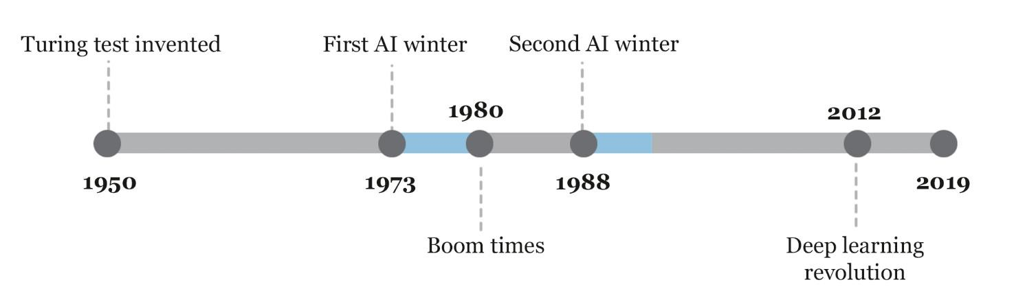

*Figure 1: Key events during the development of AI in recent time (Schuchmann, 2019)*

### 1.1.1. Machine Learning

Machine learning is an application of artificial intelligence (AI) that provides systems with the ability to automatically learn and improve from experience without being explicitly programmed. Machine learning focuses on the development of computer programs that can access data and use it to learn for themselves (Raschka, 2015). The process of learning begins with training using the data provided to make better predictions for the outcome in the future. The primary aim is to allow the computers to learn automatically without being explicitly programmed and adjust actions accordingly.

There are four types of Machine learning Techniques (Burkov, 2019) which involves different procedures for training machines:

* Supervised Learning
* Unsupervised Learning
* Re-enforcement Learning
* Semi-supervised Learning

### 1.1.2. Deep Learning

Deep learning is a class of machine learning algorithms that uses deep neural networks (ANN with multiple hidden layers) to progressively extract higher-level features from the raw input. The lower layers may identify edges, while higher layers may identify the concepts relevant to a topic. A convolutional neural network is a class of deep neural networks which is quite effective in analysing digital images. They are also known as shift invariant or space invariant artificial neural networks, based on their shared-weights architecture and translation invariance characteristics (Nielsen, 2015).

Artificial intelligence describes the algorithms that try to mimic human intelligence. Machine learning is one of the AI application where algorithms are designed to make the machine learn rather than to program every possible input, and deep learning is one of those machine learning techniques which uses multi-layer Perceptrons(Hidden Neural Networks) (Goodfellow, et al., 2016)*.*

## 1.2. Computer Vision

Computer Vision, often abbreviated as CV, is defined as a field of study that seeks to develop techniques to help computers “see” and understand the content of digital images such as photographs and videos by extracting their useful information (Prince, 2012). The problem of computer vision appears simple because but largely remains an unsolved problem based both on the limited understanding of biological vision and because of the complexity of visual perception. Due to the recent development in AI (especially Deep Learning), a vast use cases of computer vision from recognizing faces, identifying handwritten digits, surveillance, and many more have been drastically improved (Szeliski, 2011). Computer Vision discusses a wide range of topics including Image processing, Neural Networks with Multi-Layer Perceptrons and discussion of a wide range of algorithms to detect entities which is crucial for this project.

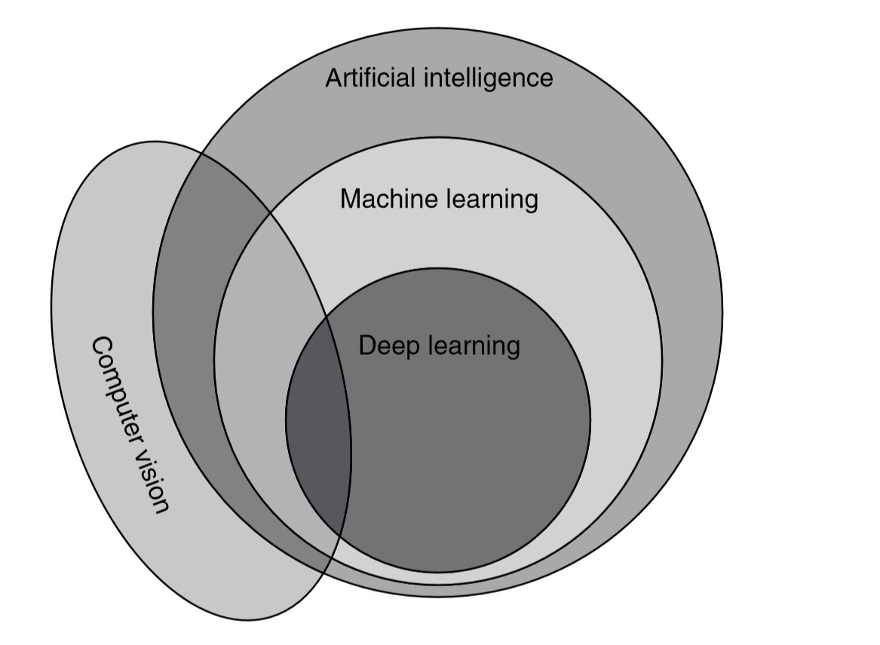

*Figure 2: Venn-diagram of AI-nomenclature and Computer vision (Qasim Aziz, et al., 2018)*

## 1.3. Cat-Dog classifying problem

The Dogs vs. Cats classification is a standard computer vision task that involves classifying photos as either containing a dog or cat using the best algorithm to run on computers. Although the problem sounds simple, it was only effectively addressed in the last few years using deep learning convolutional neural networks. While the dataset is effectively solved, it can be used as the basis for learning and practising how to develop, evaluate, and use convolutional deep learning neural networks for image classification from scratch. Also, there are plenty of works done by thousands of people who have been involved in this topic involving detailed information on creating, comparing, and in-depth mechanisms on effectively solving this problem making this topic easy to understand (Brownlee, 2019).

### 1.3.1. ASIRRA CAPTCHA

Microsoft Research (MSR) proposed the problem of discriminating cats from dogs as a test to tell humans from machines and created the ASIRRA test on this basis. The assumption is that, out of a batch of twelve images of pets, any machine would predict incorrectly the family of at least one of them, while humans would make no mistakes. The complete MSR ASIRRA system is based on a database of several million images of pets, equally divided between cats and dogs (Saul, et al., 2007). A CAPTCHA is simply a program that protects websites against bots by generating and grading tests that filters out computers. CAPTCHAs have been used extensively on the web for Preventing spams/dictionary attacks and protecting various web services prone to brute-force attacks (Carnegie Mellon University, 2010).

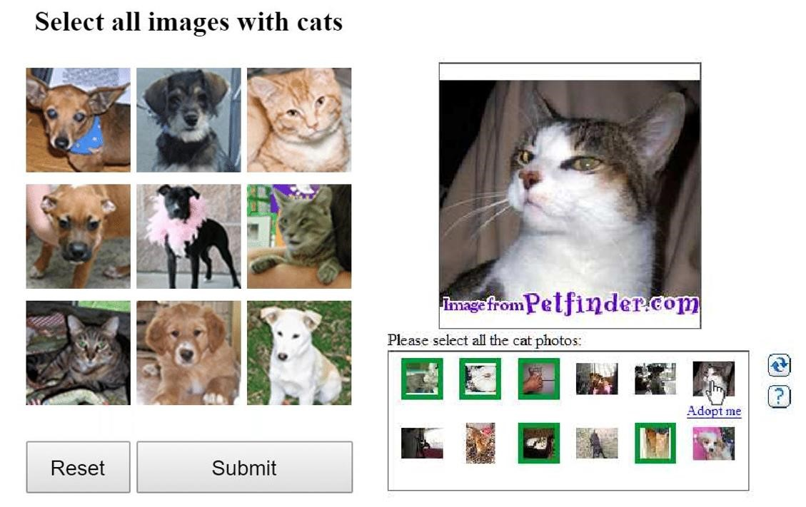

*Figure 3: Examples of ASSIRA CAPTCHA used in throughout the web*

### 1.3.2. Kaggle competition

Kaggle released a competition in 2013 to write an algorithm to classify whether images contain either a dog or a cat. This is easy for humans, but computers cannot distinguish cats and dogs by a picture. The main purpose of this competition is to recognize the limits of such a CAPTCHA system to filter out robots. The current literature suggests machine learning classifiers can score above 80% accuracy on this task so using this metric is not safe for the security of a system (Golle, 2008). Now this challenge has been set to benchmark the latest computer vision and deep learning approaches to this problem so Kaggle has released another challenge after improvement in their platform in 2016. Kaggle provided 25000 labelled pictures of dogs and cats for training and 12500 unlabelled pictures for testing in the form of zipped files. The predicted output should be recorded in a CSV file.

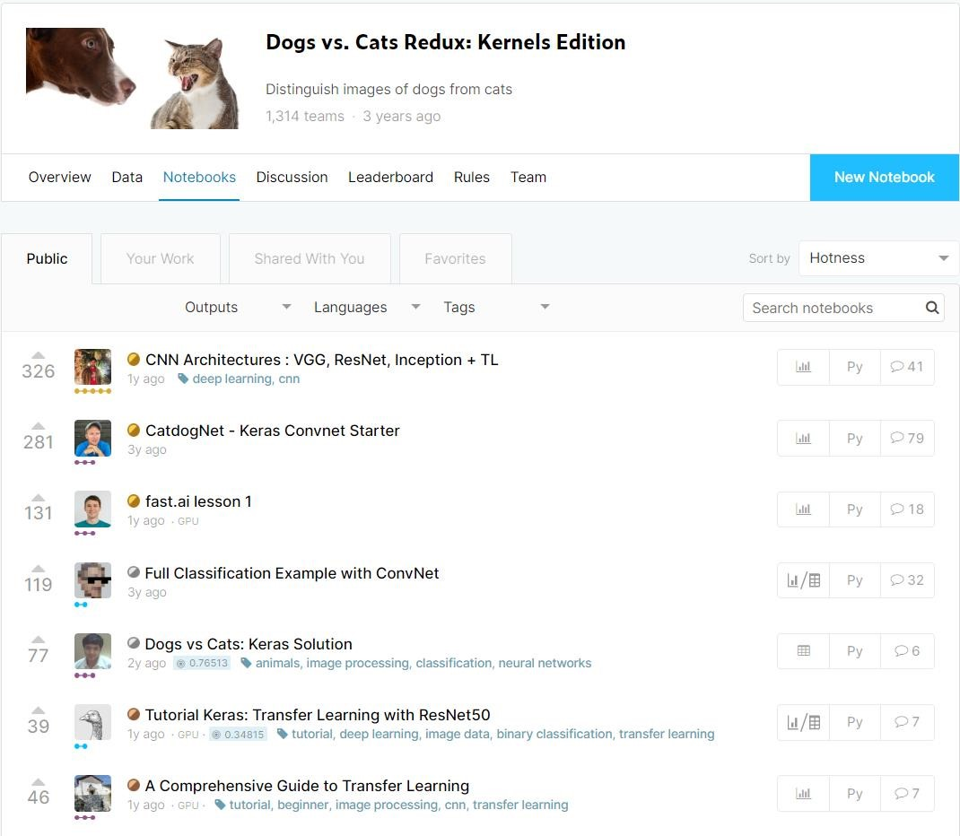

*Figure 4: Kaggle Competition for Dogs vs cats 2016 top public notebooks*

# 2. Background

## 2.1. Literature Review

To understand the topic and solve the problem various topics were gone through. Since the chosen topic is quite vast and overlaps various other topics only the fundamental basic topics required for solving the problem are described in detail.

### 2.1.1. Classification (Supervised Learning)

Supervised learning is a type of machine learning where the model is fed with enough information with labelled data for training and validating, so that, based on the learning it has done, it can predict the outcome for a new dataset in the testing phase. Classification is a technique in Machine Learning which labels the new data fed to the machine using the model created by supervised learning using the labelled previous data (Gopalakrishnan & Venkateswarlu, 2018).

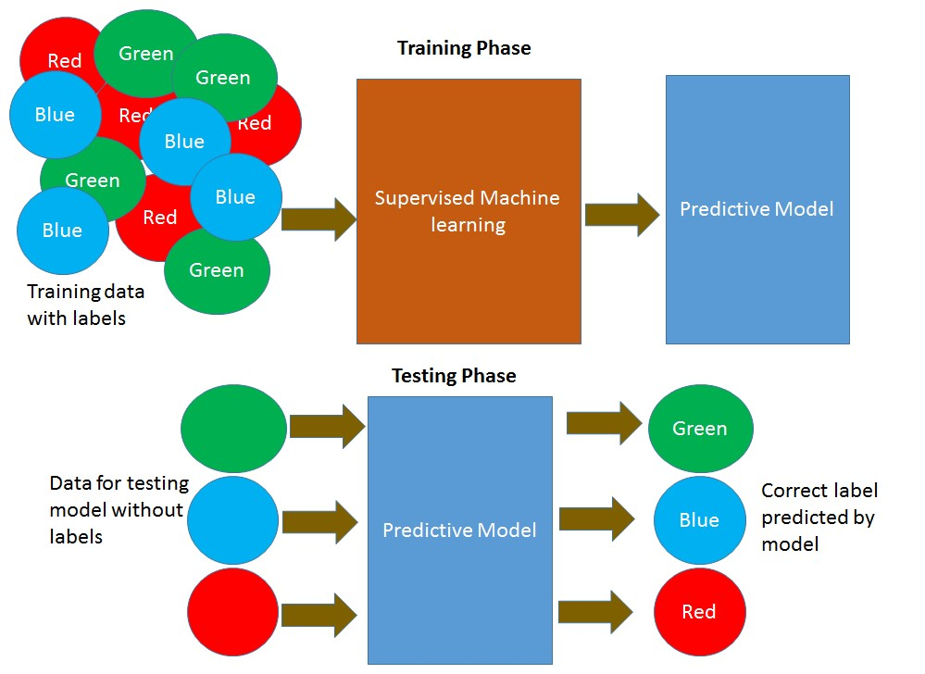

*Figure 5: Training and testing phase of the classification model using supervised learning*

### 2.1.2. Perceptron

The perceptron is the simplest form of a neural network also called an artificial neuron or simply neuron because it is modelled after the actual biological neurons found in animals, used for the separation of patterns which is said to be linearly separable (Haykin, 2003). A perceptron consists of a single neuron with adjustable synaptic weights and bias and is limited to performing classification on only two classes but if multiplying the output capability of a perceptron by using more than one this limitation can be removed. Each Perceptron in an artificial neural network has an activation function to give the final output of that neuron (Ding, et al., 2018).

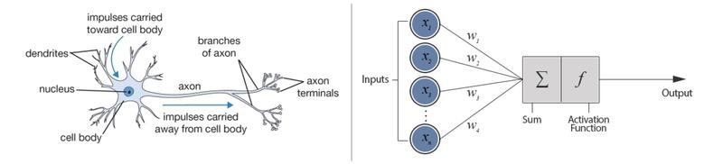

*Figure 6: A biological neuron compared with a perceptron (Willems, 2019)*

### 2.1.3. Activation Functions

Activation functions compute the weighted sum of input and biases, which is used to decide the final output of a neuron. It manipulates the presented data through some gradient processing and afterwards produces an output for the neural network, that contains the parameters in the data. These activation functions can be either linear or non-linear depending on the function it represents and is used to control the outputs of out neural networks across different domains (Marshall, et al., 2018). Most activation functions are non-linear, and they are chosen in this way on purpose as it allows the neural networks to compute arbitrarily complex functions.

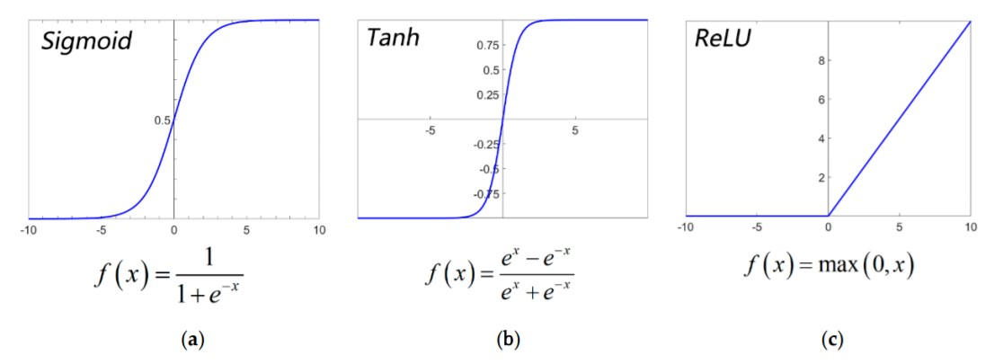

*Figure 7:Activation functions and its characteristics: (a) Sigmoid; (b) Tanh; (c) ReLU (Zhang, et al., 2019).*

### 2.1.4. Neural Networks

Neural Networks(NN) also referred to as Artificial Neural Networks(ANN) are simply networks of multiple Perceptrons loosely modelled after a biological brain. A deep neural network is a type of Artificial Neural Network architecture with one or more hidden layers(layer of neurons between the input and output layers) they are also often referred to as Multi-Layered Perceptrons due to their arrangements of neurons (Sarle, 1994). Each connection in a neural network enables the neuron to transmit a signal to other neurons. Neural networks often consist of large numbers of “neurons”.

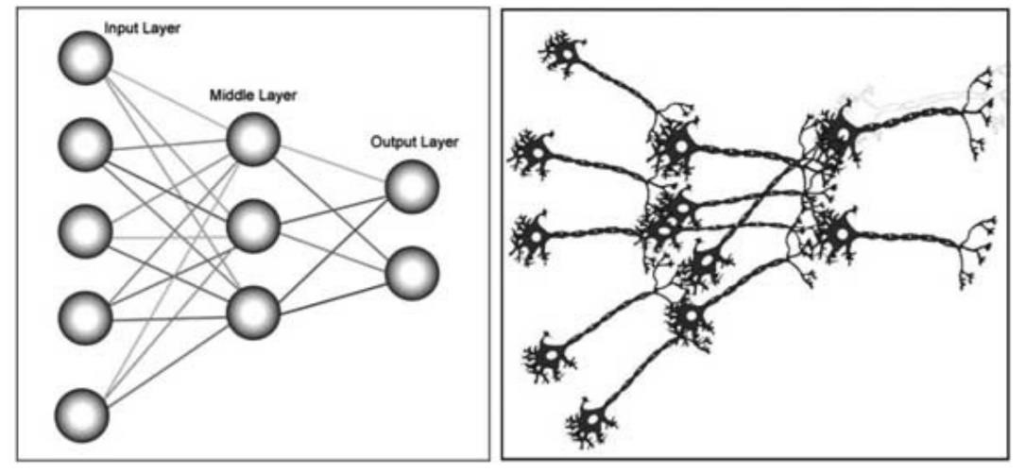

*Figure*  *8: Artificial Neural Network compared to biological neurons (Vaezzadeh, et al., 2011)*

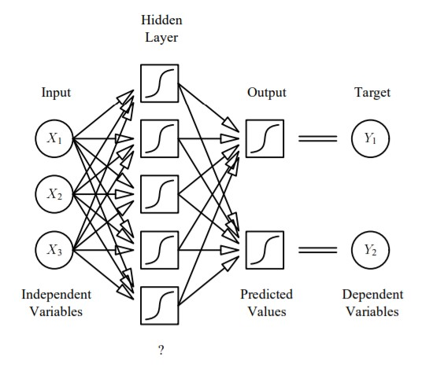

*Figure 9: Example of a deep neural network (Sarle, 1994)*

### 2.1.5. Convolutional Neural Networks

A convolutional Neural network or CNN is a special kind of Feed Forward Neural Network(FFNN) With multiple hidden layers it can be classified as a deep neural network (Burkov, 2019). CNN is designed to recognize features with a high degree of invariance to translation, scaling, skewing and other forms of distortion (LeCun & Bengio, 1995). Basically, it reduces the images into a form that is easier to process, without losing features which are critical for getting a good prediction and are specifically designed to take advantage of structure in input data. Therefore, they work so well for image processing and computer vision tasks. CNN involves feature extraction, mapping, and subsampling for recognizing images (Veeranjaneyulu & Bodapati, 2019).

### 2.1.6. LeNet-5

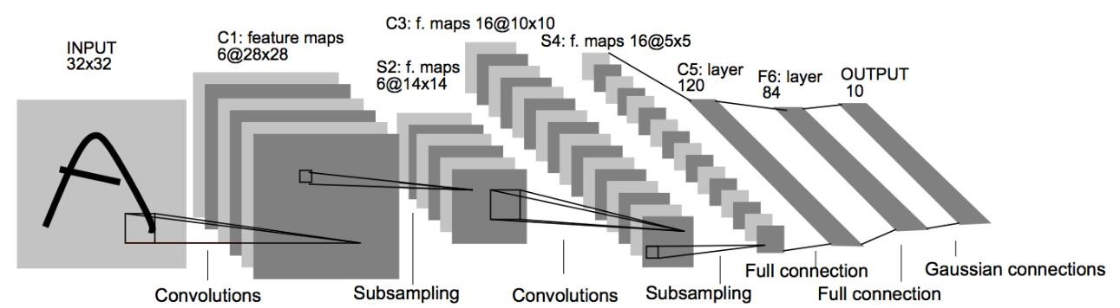

*Figure 10: Architecture of LeNet-5, an example of Convolutional Neural Network (Lecun, et al., 1998)*

The above image represents the architecture of LeNet-5 which was a popular CNN architecture. Yann LeCun, Leon Bottou, Yosuha Bengio and Patrick Haffner proposed this architecture for handwritten and machine-printed character recognition in 1998 in an article released in Proceedings of IEEE. This architecture is straightforward and simple to understand with the following layers:

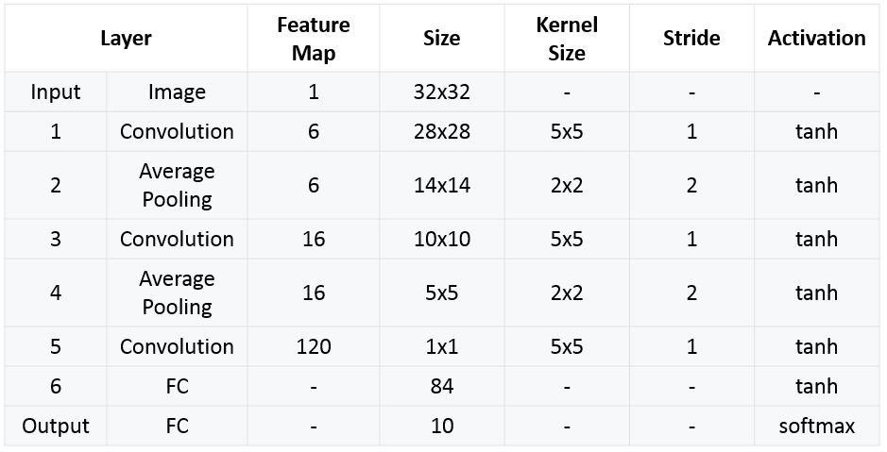

*Figure 11: LeNet-5 Architecture Summarized Table (Rizwan, 2018)*

### 2.1.7. AlexNet

AlexNet was developed by Alex Krizhevsky, Ilya Sutskever, and Geoffrey E. Hinton in 2012 to compete in the ImageNet competition. The general architecture of AlexNet is quite like LeNet-5, although this model is considerably larger. The success of this model convinced a lot of the computer vision community to take a serious look at deep learning for computer vision tasks. AlexNet used ReLU activation instead of Tanh to add non-linearity accelerating the speed, used dropout instead of regularisation to deal with overfitting (doubled training time with the dropout rate of 0.5) and most effectively used overlap pooling to reduce the size of the network (Krizhevsky, et al., 2012).

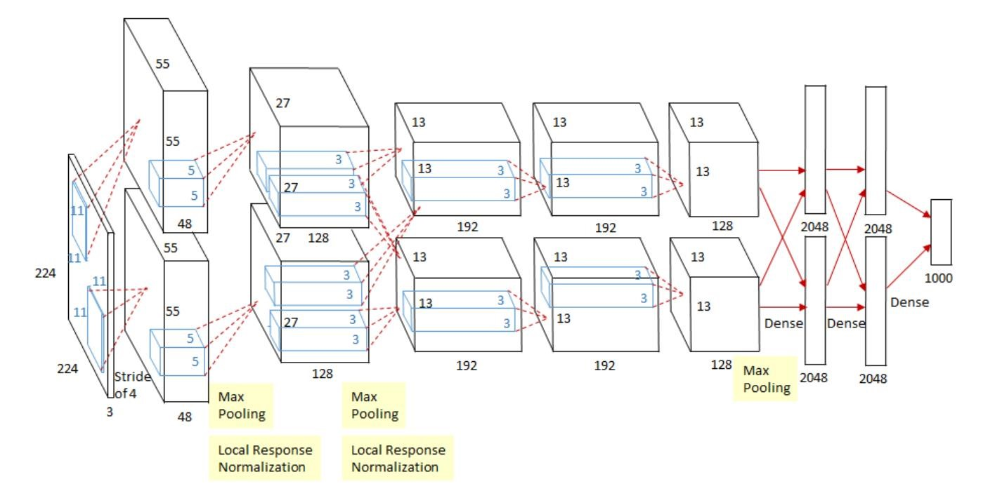

*Figure 12: AlexNet 2012 using 2 GPUs(Krizhevsky, et al., 2012)*

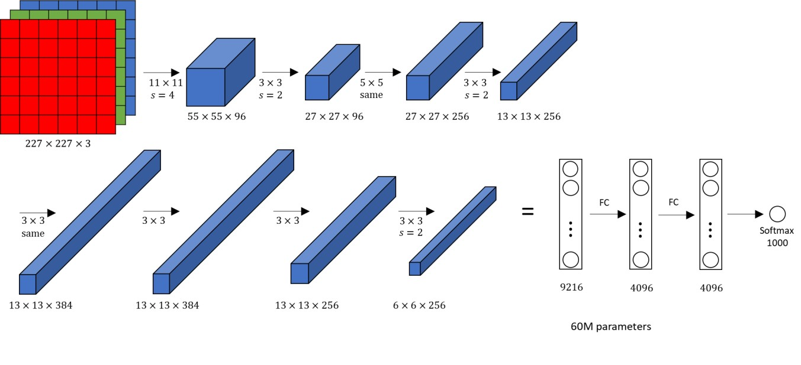

*Figure 13: AlexNet mechanism to classify colourful images (Krizhevsky, et al., 2012)*

### 2.1.8. VGG-16

After the success of AlexNet in 2012 VGG-16 or VGG-Net was introduced by Karen Simonyan and Andrew Zisserman to compete in the ImageNet challenge. This architecture was the First runnerup after Google’s GoogleNet architecture. Its main contribution was in showing that the depth of the network is a critical component for good performance. VGG-16 contained 13 convolutional layers, 5 pooling layers, and 3 dense layers. VGG-16 features an extremely homogeneous architecture that only performs 3x3 convolutions and 2x2 pooling from the beginning to the end. The downsides of the VGG16 are that it is more expensive to evaluate and uses a lot more memory, parameters (140 Million) and produces a model with large size. Most of these parameters are in the first fully connected layer, and it was since found that these FC layers can be removed with no performance downgrade, significantly reducing the number of necessary parameters (Zisserman & Simonyan, 2014).

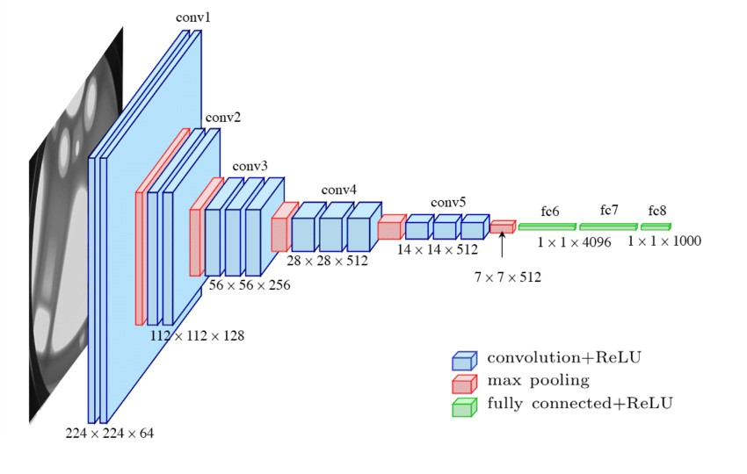

*Figure 14: Standard VGG-13 Architecture (Ferguson, et al., 2017)*

This architecture is chosen in this project since it is simple, but an effective model compared to the other primitive ones. Since the rise of the development in neural networks, there has been a lot of development in the CNN architectures causing a lot of the new effective architecture to appear. Some of the newer popular architectures are MobileNet, Resnet-18, DenseNet, and InseptionNet. The comparison between VGG-16 and various other popular architectures are presented in the figure below with respect to the top-5 accuracy scores and operations in the architectures.

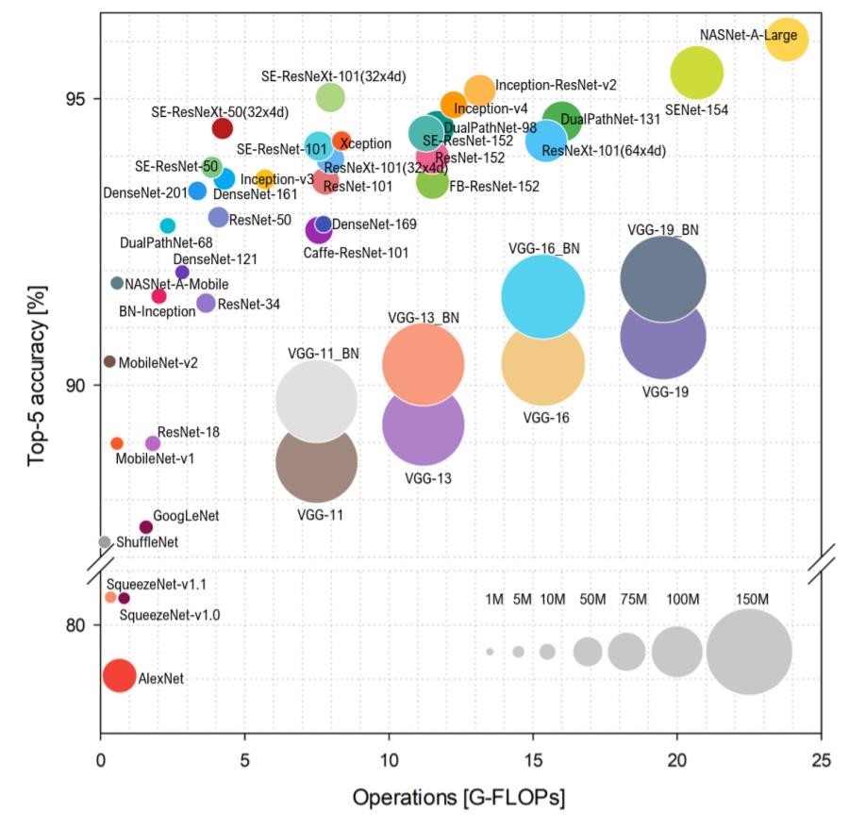

*Figure 15: Comparison between various CNN Architectures in terms of top-5 accuracy and operation (Bianco, et al., 2018)*

### 2.1.9. CNN layer types

Any CNN architecture requires to be carefully modelled with various layers which will increase the contrast to the features gradually and carefully reduces the image file to a single dimension to give the final output. The various general layers used in CNN are as follows the convolution operation and max-pooling is detailed after this section:

#### 1. Input layer

The layer takes the input usually in the form of an image.

1. **Convolutional layer:**

The convolutional layer serves to detect (multiple) patterns in multiple sub-regions in the input field using receptive fields between neurons. Simply, it computes the dot product between the weights and a small patch in the output of the previous layer (Marco & Farinella, 2018).

1. **Rectified Linear Unit layer:**

This layer applies an activation function to the output of the previous layer to add non-linearity to the network so that it can generalize well to any type of function (Campbell, 2017).

1. **Pooling layer:**

The pooling layer serves to progressively reduce the spatial size of the representation, to reduce the number of parameters and amount of computation in the network. The pooling layer operates on each feature map independently. Max pooling is frequently used in the pooling layer the maximum value in a given in height-width measurements (Marco & Farinella, 2018).

#### 5. Dense layer

The dense layers in a CNN are usually 2-3 layers of MLP that that is used to map activation volume from the combination of previous layers into a class probability distribution (Karim, et al., 2018).

### 2.1.10. Convolution Operation in convolutional Layer

Convolution is the process of adding each element of the image to its local neighbours, weighted by the kernel and is related to mathematical convolution operation. The convolutional layer simply makes edges and details sharper, by multiplication of the part of the image to a same-sized kernel matrix also known as convolution matrix or mask. A kernel matrix is a matrix which when multiplied with the same sized part of the image will produce the new image with added effects. This effect can be used to sharpen, blur or enhance edges in images. A convolution operation will reduce the size of the image but can easily be mitigated by adding a masking layer to the input image to give an output of the same size (Goodfellow, et al., 2016).

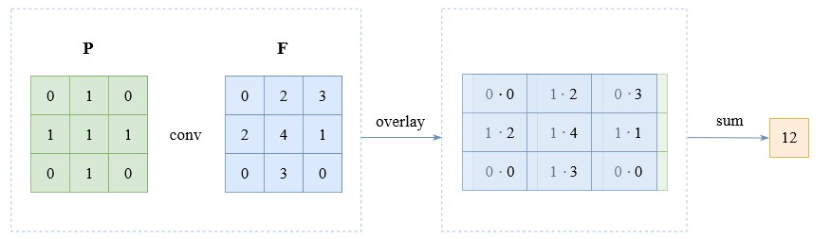

*Figure 16: A Convolution Operation (Burkov, 2019)*

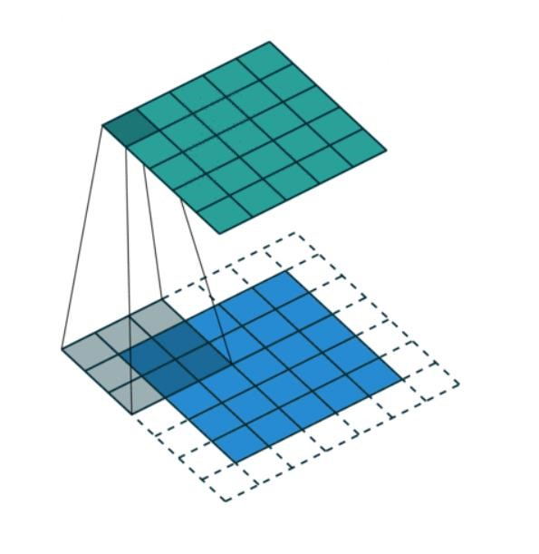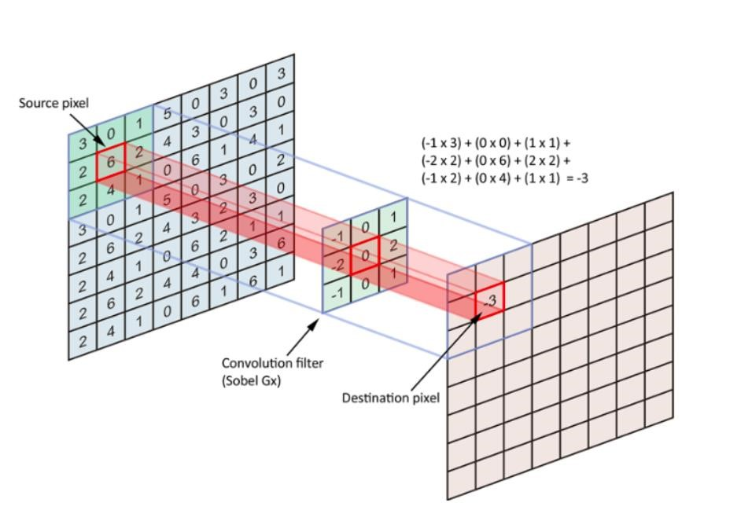

*Figure 18: Convolution filter applied in a part of image (Burkov, 2019) Figure 17:Using padding before convolution*

*(Campbell, 2017)*

### 2.1.11. Max Pooling in Pooling Layer

Pooling is like convolution, as a filter applied using a sliding window approach. However,

instead of applying a trainable filter to an input matrix or a volume, the pooling layer applies a fixed operator, usually either max or average. Similarly, to convolution, pooling has hyperparameters: the size of the filter and the stride. An example of max pooling with filter of size 2 and stride 2 is by shrinking the 2 by 2 matrix to a single maximum value within the matrix as shown in figure 19. Usually, a pooling layer is applied after a convolution layer to highlight the main feature. Unlike convolution operation, when pooling is applied to a volume, each matrix in the volume is processed independently of others. Therefore, the depth of the volume is conserved in pooling. Max pooling is used more often than average and often gives better results by highlighting the main feature and decreasing the chance of overfitting. Pooling contributes to the increased accuracy of the model and improves the speed of training due to the reduction in the number of parameters of the neural network (Burkov, 2019).

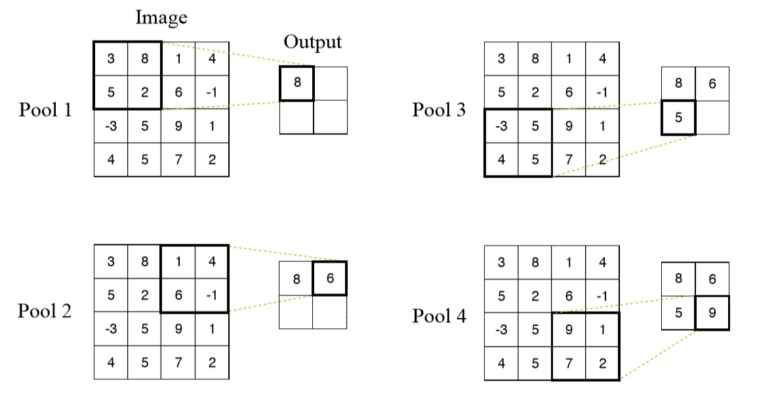

*Figure 19: Max-pooling with the size of 2 and stride of 2 (Burkov, 2019)*

## 2.2. Existing Works:

Since the dog’s vs cat’s classification was a world-wide competition, there are thousands of solutions created. Among them, there were various notebooks that are quite useful for understanding the problem in depth. The most notable source was Kaggle and there are also many blogs and online instructions on solving the problem. The guides and notebooks are discussed more in Appendix (A). The Dog-cat classifier might not seem a serious topic but the underlying mechanism in this classification problem can be used to tackle various image classification problems. CNN can be used in Facial Recognition, analysing medical imagery, understanding Climate, OCR and many more.

### 2.2.1. ML binary classifier for gastrointestinal disease

. Binary classifiers aim to stratify allocation to a categorical outcome, such as the presence or absence of gastrointestinal disease. This will help in data-driven procedures to detect the disease. Furthermore, such analyses could predict the development of GI disease prior to the manifestation of symptoms, raising the possibility of prevention or pre-treatment. This defines the recent developments in healthcare-based AI/machine learning and its essence in this field. This is one of the many applications of Computer Vision in the medical field (Qasim Aziz, et al., 2018).

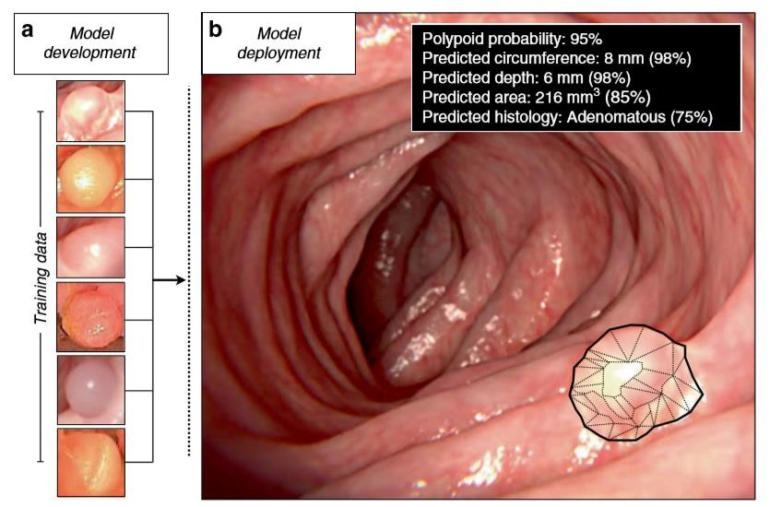

*Figure 20: Application of CV to detect GI images (Qasim Aziz, et al., 2018)*

### 2.2.2. CNN for Optical Character Recognition

One of the most frequent use cases of CNN is to digitalize hard copy data to soft copy (digital format). A simple CNN architecture can be used to detect a single letter that can then be used in a loop to detect a whole sentence. This has been used in Text-To-Speech Engines and Translation. This was first proposed by LeCun in his paper “Gradient-Based Learning Applied to Document Recognition” (Lecun, et al., 1998) which is discussed in LeNet-5 CNN architecture.

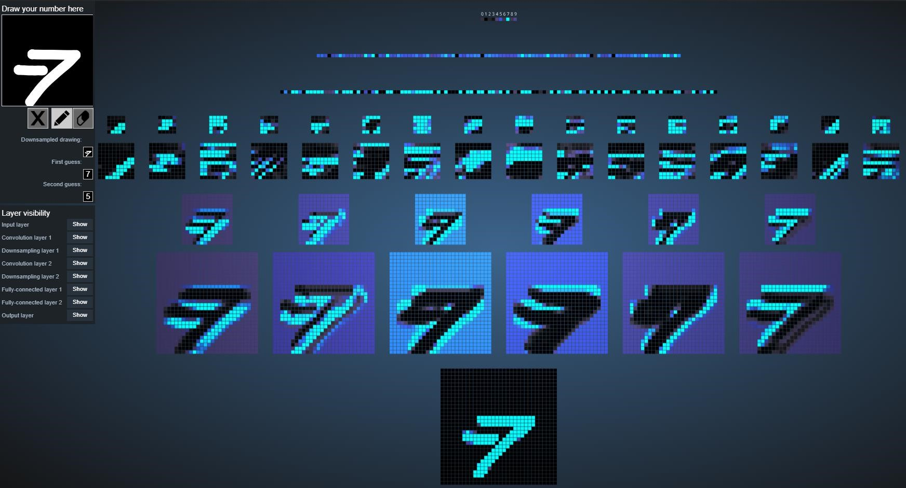

*Figure 21: Visualization of a simple CNN architecture for digit recognition*

# 3. Solution

Usually, in the past years, various methods were used to verify humans over automated bots on the internet like the ASSIRA CAPTCHA. But since the rise of the AI techniques, this technique has been obsolete. There have been more advantages of the existence of such an algorithm because now humans can automate machines on doing things that were thought to be impossible. The same algorithm used for classifying cats and dogs apart can be reused to create a more serious application that detects cancer by looking at the images, can identify faults in places humans are unable to reach and many more. The whole problem and the format of the solution are well defined in the previous section. This section describes the plan to fit the research done to tackle the problem by addressing all the concerns.

The tools to be used in the building phase are discussed in Appendix B.

## 3.1. Proposed solution:

The problem can easily be solved by fine-tuning a pretrained model with the training data of dogs and cats. Then to solve the given problem the following steps will be taken:

* Data Gathering (From Kaggle)
* Installing required libraries and dependencies
* Analysing datasets
* Preparing Data
* Preparing model using Transfer Learning (Use pre-existing module& fine-tune)
* Dividing the train-datasets into training-dataset and validation-dataset
* Training the model using the training data set
* Observing results on the validation data
* Finally using the trained model to classify testing data
* Recording classified test data details in CSV

## 3.2. Application of CNN to solve this problem

This section elaborates the use of CNN to solve the problem and elaborates all the required details on how it will be modelled. This section also discusses the methods to calculate the accuracy of the model’s performance.

### 3.2.1. Proposed CNN architecture (VGG-16)

The main architecture to be used in this project will be VGG-16 which was discussed in the background section. This will have 13 convolutional layers, 4 pooling layers, and 3 dense layers. This architecture is quite effective for classifying RGB images (Zisserman & Simonyan, 2014).

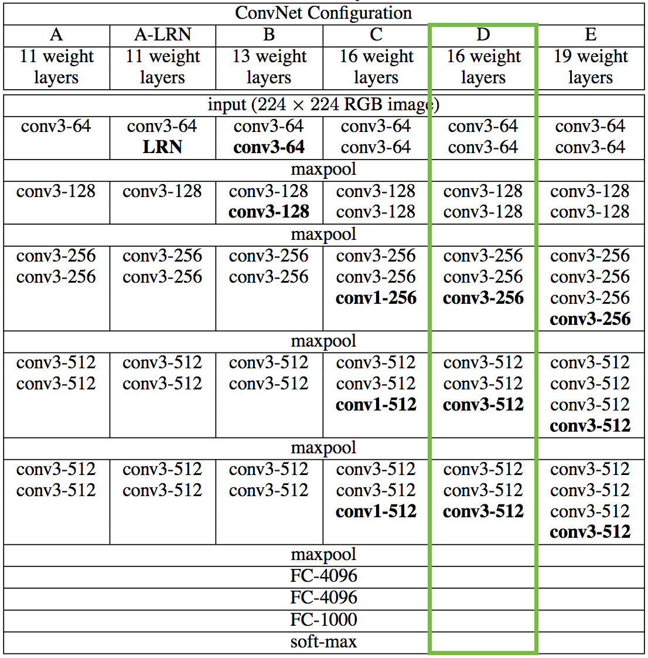

*Figure 22: VGG-16 architecture details (Zisserman & Simonyan, 2014)*

### 3.2.2. VGG-16 Transfer Learning

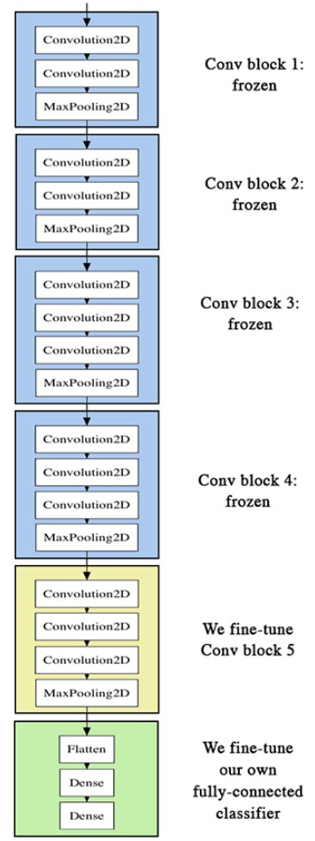Transfer learning is a reusing developed model for another task. This can be quite helpful considering the huge size of VGG-16. Instead of training the whole model we can fine-tune the last 7 layers to make the whole process faster as shown in Figure 14 (Chollet, 2016).

There are various notebooks with VGG-16 used as the core architecture in them. Since VGG16 is a quite bulky architecture, most of the participants had used a transfer learning technique. This allowed them to use pre-existing modules and only train specific parts of the VGG-16 module to get the best results.

*Figure 23: Transfer learning on VGG-16 (Chollet, 2016)*

### 3.2.3. Confusion Matrix to calculate Validation accuracy

A confusion matrix is often used to describe the performance of a classification model on a set of test data for which the true values are known(usually on the validation set) in form of a table. The confusion matrix itself is relatively simple to understand and helps in the calculation of various important metrics such as Accuracy, Misclassification Rate, Precision, Prevalence, True Positive Rate, True Negative Rate, False Positive Rate, and False Negative Rate. A ROC curve can also be plotted using the data from a confusion matrix over several iterations(epochs) during the training process (Data School, 2014).

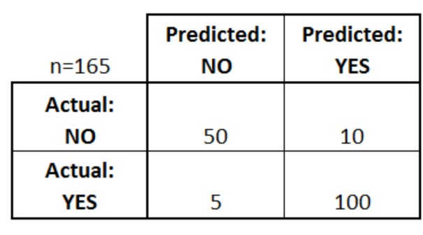

*Figure 24: An Example of Confusion Matrix*

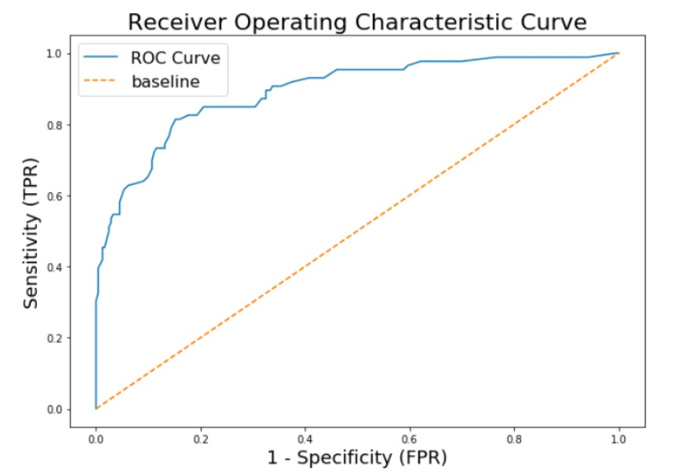

*Figure 25: An Example of a ROC Curve (Chazhoor, 2019)*

## 3.3. Pseudocode

IMPORT VGG-16

IMPORT Linear Algebra library

IMPORT CSV handling library

IMPORT 2D Plot

IMPORT training_data = [labelled data]

IMPORT testing_data = [unlabeled data]

DEFINE VGG-16 model: model.ADD(CONVOLUTIONAL_LAYER(input_dim=(224,224,3),neurons=64, activation = RELU)) model.ADD(CONVOLUTIONAL_LAYER(neurons=64, activation = RELU)) model.ADD(POOLING_LAYER(pool_size=(2,2),strides=(2,2))) model.ADD(CONVOLUTIONAL_LAYER(neurons=128, activation = RELU)) model.ADD(CONVOLUTIONAL_LAYER(neurons=128, activation = RELU)) model.ADD(POOLING_LAYER(pool_size=(2,2),strides=(2,2))) model.ADD(CONVOLUTIONAL_LAYER(neurons=256, activation = RELU)) model.ADD(CONVOLUTIONAL_LAYER(neurons=256, activation = RELU)) model.ADD(CONVOLUTIONAL_LAYER(neurons=256, activation = RELU)) model.ADD(POOLING_LAYER(pool_size=(2,2),strides=(2,2))) model.ADD(CONVOLUTIONAL_LAYER(neurons=512, activation = RELU)) model.ADD(CONVOLUTIONAL_LAYER(neurons=512, activation = RELU)) model.ADD(CONVOLUTIONAL_LAYER(neurons=512, activation = RELU)) model.ADD(POOLING_LAYER(pool_size=(2,2),strides=(2,2))) model.ADD(CONVOLUTIONAL_LAYER(neurons=512, activation = RELU)) model.ADD(CONVOLUTIONAL_LAYER(neurons=512, activation = RELU)) model.ADD(CONVOLUTIONAL_LAYER(neurons=512, activation = RELU)) model.ADD(POOLING_LAYER(pool_size=(2,2),strides=(2,2)))

accuracy = 0 validation_data = [20% of training_data] while accuracy < 80:

model TRAIN(VGG-16(training_data)) FOR each_data IN validaion_data: label = each_data.LABEL() confusion_matrix.APPEND(label, model.PREDICT(each_data)) accuracy = ACCURACY(confusion_matrix)

FOR each_data IN testing_data: label = each_data.LABEL()

CSV.Write(label, model.PREDICT(each_data))

## 3.4. Flowchart

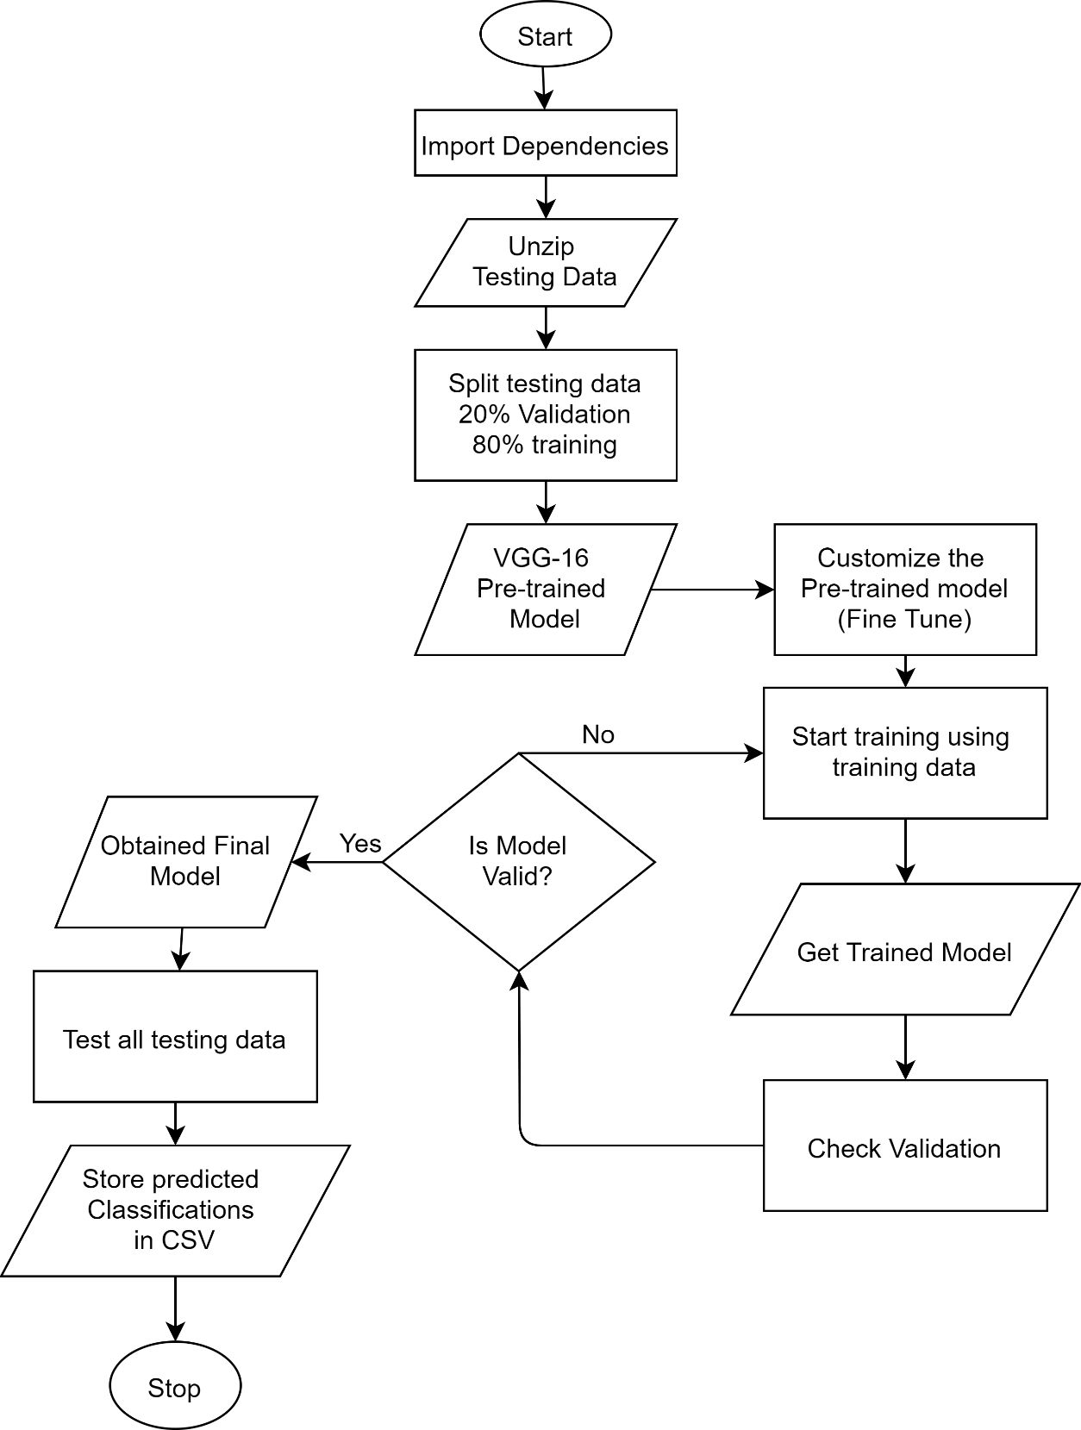

*Figure 26: Flow-chart of the solution*

# 4. Conclusion

This report discusses in detail how Deep learning methods can be used to solve image classification problems and how a system used for differentiating computers and humans are slowly becoming more obsolete. The use of ASIRRA CAPTCHA in 2008 and its failure due to the machine getting features to classify images is discussed. The Kaggle competition is also introduced in this report and the structure of the solution. Dogs vs cats is a classic Deep Neural Network exercise for beginners.

This topic is a good example of the Application of Computer Vision to solve real-world problems.

The background portion elaborates more on the basic Deep learning concepts such as neurons, activation function, Artificial Neural Networks, Forward Propagation and convolutional neural networks. Since this project is based on Convolutional Neural Network, the first proposed convolutional neural network architecture LeNet-5, and the modern AlexNet with ReLU activation is also discussed with causing the rapid development in CNN today. After these classic CNN models another simple but deep network, VGG-16 is also discussed which is quite effective in terms of classifying images. The various layers of CNN are discussed along with in-depth analysis of how convolution and max-pooling works. The importance of Convolution operation and max-pooling is also defined. After all the basic concepts are discussed the application of CNN is explored where it was found to be quite essential in the modern days from recognizing digits to detecting disease from digital imagery.

After all the Literature reviews and extensive research, it was found that this image classification problem can easily solved by using pretrained model for VGG-16. So, to create a working application out of all the research conducted a rough sketch for the solution is proposed with elaborate Pseudocode and a simple flowchart representing the underlying logic of the overall system.

Therefore, most of the required information for creating and implementing CNN was discussed now a working application using the pretrained model must be implemented in the upcoming project. Understanding most of the details about the model and its inner mechanism will greatly help the development process and this application can also be used to classify various other problems except just Dogs and cats after completion (i.e. The training data can be swapped with other examples and it will still work).

# 5. References

Bansal, S., 2019. *CNN Architectures : VGG, ResNet, Inception + TL.* [Online]

Available at: https://www.kaggle.com/shivamb/cnn-architectures-vgg-resnet-inception-tl [Accessed 10 January 2020].

Bianco, S., Cadène, R., Napoletano, P. & Luigi , C., 2018. Benchmark Analysis of Representative Deep Neural Network Architectures. *IEEE Access,* 6(1), pp. 64270-64277.

Brownlee, J., 2019. *How to Classify Photos of Dogs and Cats (with 97% accuracy).* [Online] Available at: https://machinelearningmastery.com/how-to-develop-a-convolutional-neural-network-toclassify-photos-of-dogs-and-cats/ [Accessed 10 January 2020].

Built in, 2019. *Artificial Intelligence, What is Artificial Intelligence? How Does AI Work?.* [Online] Available at: https://builtin.com/artificial-intelligence [Accessed 9 January 2020].

Burkov, A., 2019. *The hundred-page machine learning book.* First ed. Quebec: Andriy Burkov.

Campbell, R., 2017. *Demystifying Deep Neural Nets.* [Online]

Available at: https://medium.com/@RosieCampbell/demystifying-deep-neural-nets-efb726eae941 [Accessed 9 January 2020].

Carnegie Mellon University, 2010. *CAPTCHA: Telling Humans and Computers Apart Automatically.*

[Online]

Available at: http://www.captcha.net/ [Accessed 10 January 2020].

Chazhoor, A. P., 2019. *ROC curve in machine learning.* [Online]

Available at: https://towardsdatascience.com/roc-curve-in-machine-learning-fea29b14d133 [Accessed 12 January 2020].

Chollet, F., 2016. *Building powerful image classification models using very little data.* [Online]

Available at: https://blog.keras.io/building-powerful-image-classification-models-using-very-little-data.html [Accessed 12 January 2020].

Data School, 2014. *Simple guide to confusion matrix terminology.* [Online]

Available at: https://www.dataschool.io/simple-guide-to-confusion-matrix-terminology/ [Accessed 12 January 2020].

Deeplizard, 2017. *Activation Functions in a Neural Network explained.* [Online]

Available at: https://deeplizard.com/learn/video/m0pIlLfpXWE [Accessed 10 January 2020].

Ding, B., Qian, H. & Zhou, J., 2018. *Activation functions and their characteristics in deep neural networks.*

Shenyang, IEEE.

Ferguson, M., ak, R., Yung-Tsun, L. & Kincho, L., 2017. *Automatic localization of casting defects with convolutional neural networks.* s.l., s.n.

Golle, P., 2008. *Machine Learning Attacks Against the Asirra CAPTCHA.* Palo Alto, Palo Alto Research Center.

Goodfellow, I., Courville, A. & Bengio, Y., 2016. *Deep Learning.* First ed. Boston: MIT Press.

Gopalakrishnan, R. & Venkateswarlu, A., 2018. *Types of learning.* [Online] Available at:

https://subscription.packtpub.com/book/big_data_and_business_intelligence/9781788629355/1/ch01lvl1s ec12/types-of-learning

[Accessed 10 January 2020].

Haykin, S., 2003. *Neural Networks A comprehensive Foundation.* Second ed. New Delhi: Prentice.

Karim, E., Neehal, N., Foysal, A. F. & Islam, S. M., 2018. *InceptB: A CNN Based Classification Approach for Recognizing Traditional Bengali Games.* Kochi, International Conference on Advances in Computing & Communications.

Krizhevsky, A., Sutskever, I. & Hinton, G. E., 2012. *ImageNet Classification with Deep Convolutional Neural Networks,* Toronto: University of Toronto.

LeCun, Y. & Bengio, Y., 1995. *Convolutional Networks for Images, Speech, and Time-Series.,* Holmdel:

AT&T Bell Laboratories.

Lecun, Y., Bottou, L., Yoshua , B. & Haffner, P., 1998. *Gradient-Based Learning Applied to Document Recognition,* New York: Proceedings of the IEEE.

Marco, L. & Farinella, M. G., 2018. *Computer Vision for Assistive Healthcare.* First ed. Amsterdam:

Elsevier.

Marshall, S., Nwankpa, C. E., Gachagan, A. & Ijomah, W., 2018. *Activation Functions: Comparison of Trends in Practice and Research for Deep Learning,* Chicago: ArXiv.

Nielsen, M. A., 2015. *Neural Networks and Deep Learning.* First ed. s.l.:Determination Press.

Norvig, P. & Russell, S. J., 2003. *Artificial Intelligence: A Modern Approach.* Second ed. New Delhi:

Prentice Hall/Pearson Education.

Prince, S. J., 2012. *Computer Vision: Models, Learning, and Inference.* First ed. London: Cambridge University Press.

Qasim Aziz, Farmer, A. D. & Ruffle, J. K., 2018. Artificial Intelligence-Assisted gastroenterology Promises and Pitfalls. *American Journal of Gastroenterology,* pp. 1-7.

Raschka, S., 2015. *Python Machine Learning.* First ed. Birmingham: Packt Publishing.

Rizwan, M., 2018. *LeNet-5 – A Classic CNN Architecture.* [Online] Available at: https://engmrk.com/lenet-5-a-classic-cnn-architecture/ [Accessed 12 January 2020].

Sarle, W. S., 1994. *Neural Networks and Statistical Models.* Cary, SAS Institute Inc..

Saul, J., Elson, J., Douceur, J. R. & Howell, J., 2007. *Asirra: A CAPTCHA that Exploits Interest-Aligned Manual Image Categorization.* San Fransisco, Microsoft Research.

Schuchmann, S., 2019. *History of the first AI Winter.* [Online]

Available at: https://towardsdatascience.com/history-of-the-first-ai-winter-6f8c2186f80b [Accessed 10 January 2020].

Szeliski, R., 2011. *Computer Vision Algorithms and Applications.* First ed. London: Springer-Verlag London Limited.

Vaezzadeh, M., Saeidi, M., Firouzkhani, A. & Hajnorouzi, A., 2011. Alzheimer Treatment by Applying Ultrasound Waves. *Current Signal Transduction Therapy,* 1(6), pp. 424-427.

Veeranjaneyulu, N. & Bodapati, J. D., 2019. Feature Extraction and Classification Using Deep Convolutional Neural Networks. *Journal of Cyber Security and Mobility,* 8(2), pp. 261-276.

Willems, K., 2019. *Keras Tutorial: Deep Learning in Python.* [Online]

Available at: https://www.datacamp.com/community/tutorials/deep-learning-python [Accessed 10 January 2020].

Zhang, Q. et al., 2019. Potential for Prediction of Water Saturation Distribution in Reservoirs Utilizing Machine Learning Methods. *Energies,* 12(19), p. 3597.

Zisserman, A. & Simonyan, K., 2014. *Very Deep Convolutional Networks for Large-Scale Image Recognition,* Oxford: arXiv.

# Appendix

**Appendix A**

**Kaggle Notebooks:**

The notebook created by Harrison Kinsley (Sentdex) features a simple CNN architecture with a well-written set of guides and videos explaining the procedure of creating the cot-dog classifier. This notebook uses low-level TensorFlow as the core deep learning and is a good example of the solution.

The notebook created by user Kaggle user Navi demonstrates the performance of Transfer learning VGG-16 in Pytorch. Similarly, user Andrés Larroza does the same using Keras.

The notebook created by Shivan Bansal compared various CNN architectures and plotted the results displaying the effectiveness of the various architectures (Bansal, 2019).

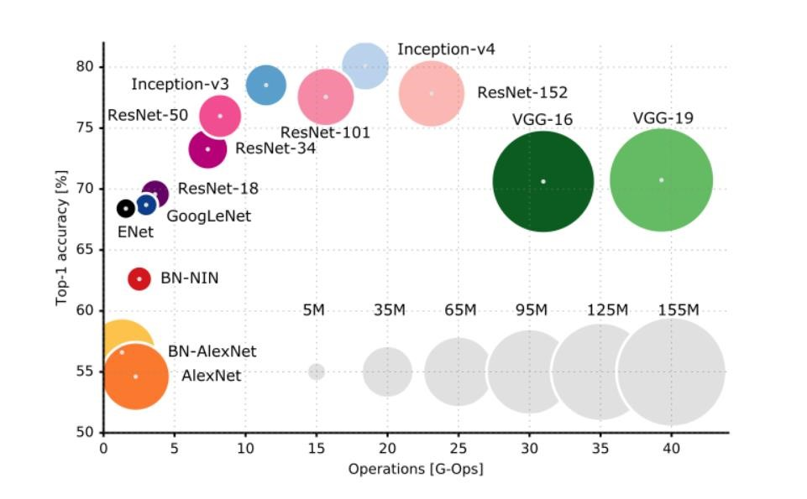

*Figure 27: CNN Architectures performance on Dogs vs cats comparison (Bansal, 2019)*

**Appendix B**

#### Deep learning Frameworks and tools

The following tools are considered to solve the following problem:

|  |  |
| --- | --- |
| **Tool** | **Description** |
| TensorFlow | TensorFlow is the core open-source library to develop and train ML models |
| Pytorch | PyTorch is an optimized tensor library for deep learning using GPUs and CPUs like TensorFlow. |
| Keras | Keras is a high-level neural networks API, capable of running on top of TensorFlow, CNTK, or Theano. |
| Pandas | Pandas is an open-source library providing various data analysis tools for Python. |
| NumPy | NumPy is the library providing vital tools for matrix and array operations. It makes Linear Algebra tasks exponentially easier. |
| Nvidia CUDA | NVIDIA CUDA is a parallel computing platform and programming model developed by NVIDIA. It is used for boosting the ML process by utilizing CUDA enabled GPUs. |
| Mat Plot Lib | Matplotlib is a Python 2D plotting library which produces charts and figures essential for data science projects. |
| Jupyter Notebook | The Jupyter Notebook is a web application that allows you to create and share documents that contain live code, equations, visualizations and narrative text making machine learning tasks easier. |
| Google Colab | Google Colab is another web application built on top of Jupiter notebook, provided by Google. It provides online kernels (remote virtual computers) which is quite useful when on limited resources and working on teams. |
| Kaggle Kernel | Kaggle Kernel is another Google Colab like a web application that also provides GPU computing and seamless integration with Kaggle services (loading data). |
| Miniconda | Miniconda is a minimal installer for conda providing most of the essential packages required for Data Science projects. This package is also useful for managing python virtual environments. |